Ethernet Cable RJ45 - Straight Through &amp; Crossover

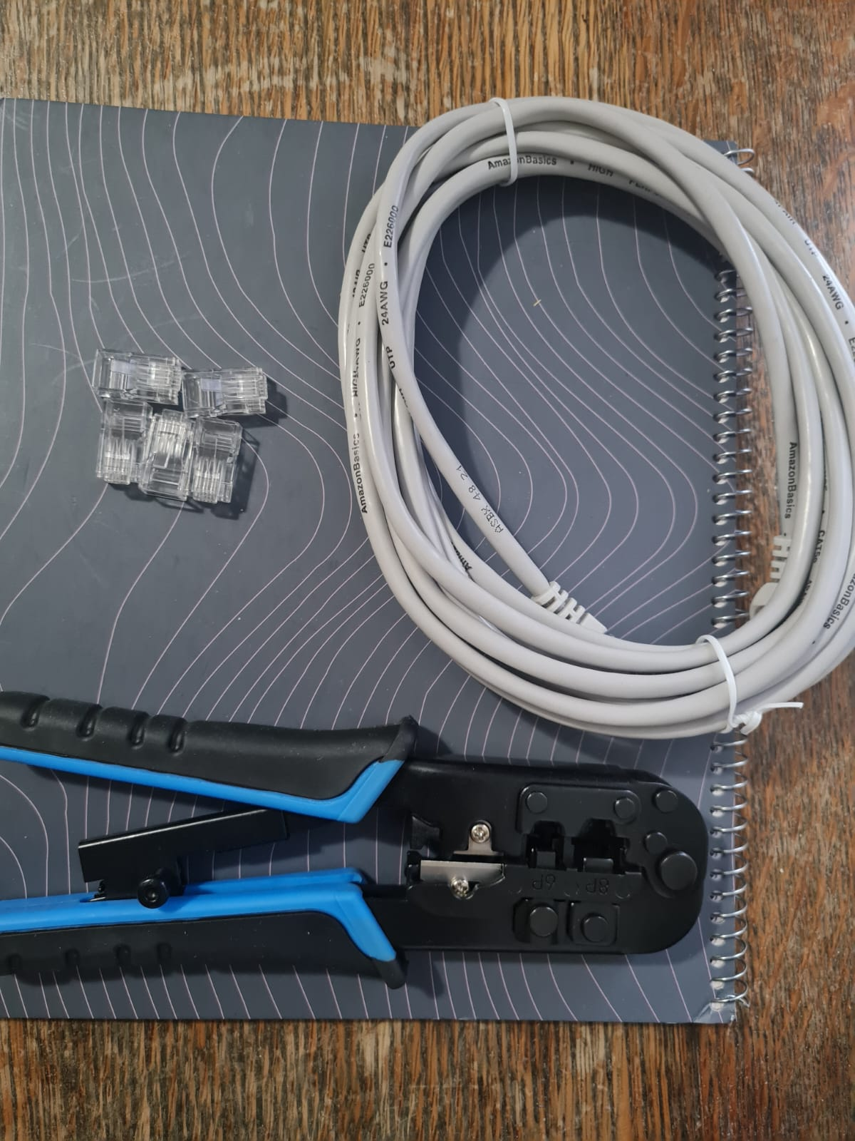
Crossover Cable – TIA/EIA 568A
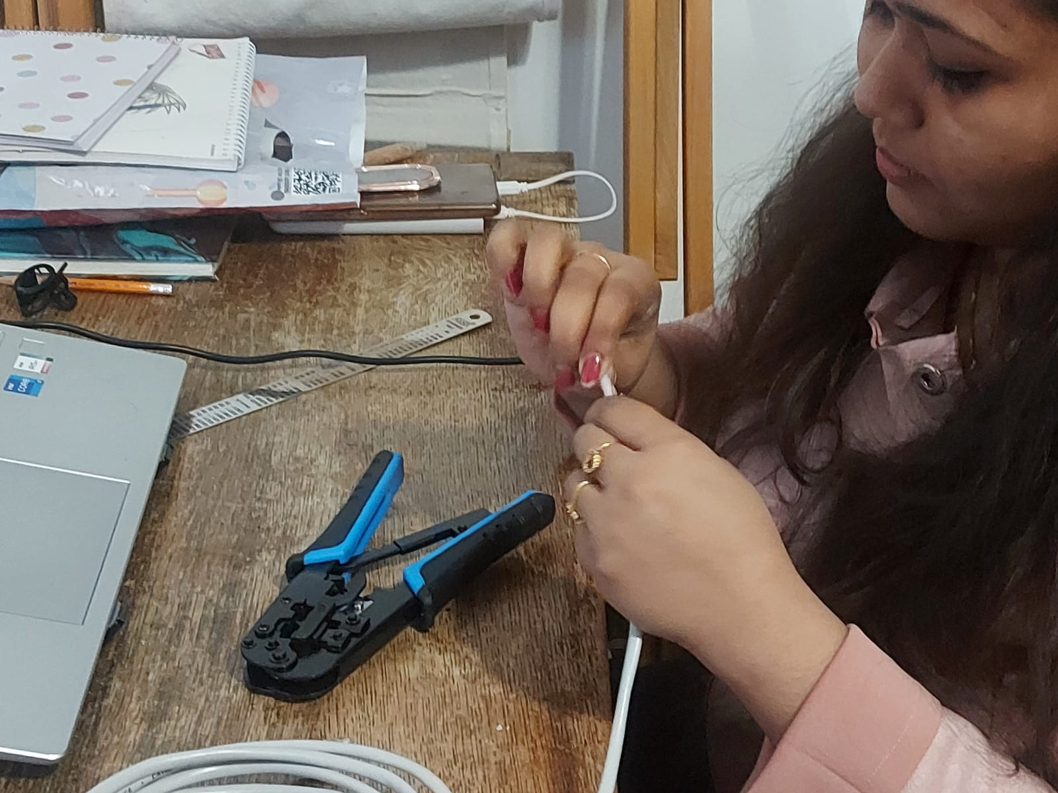
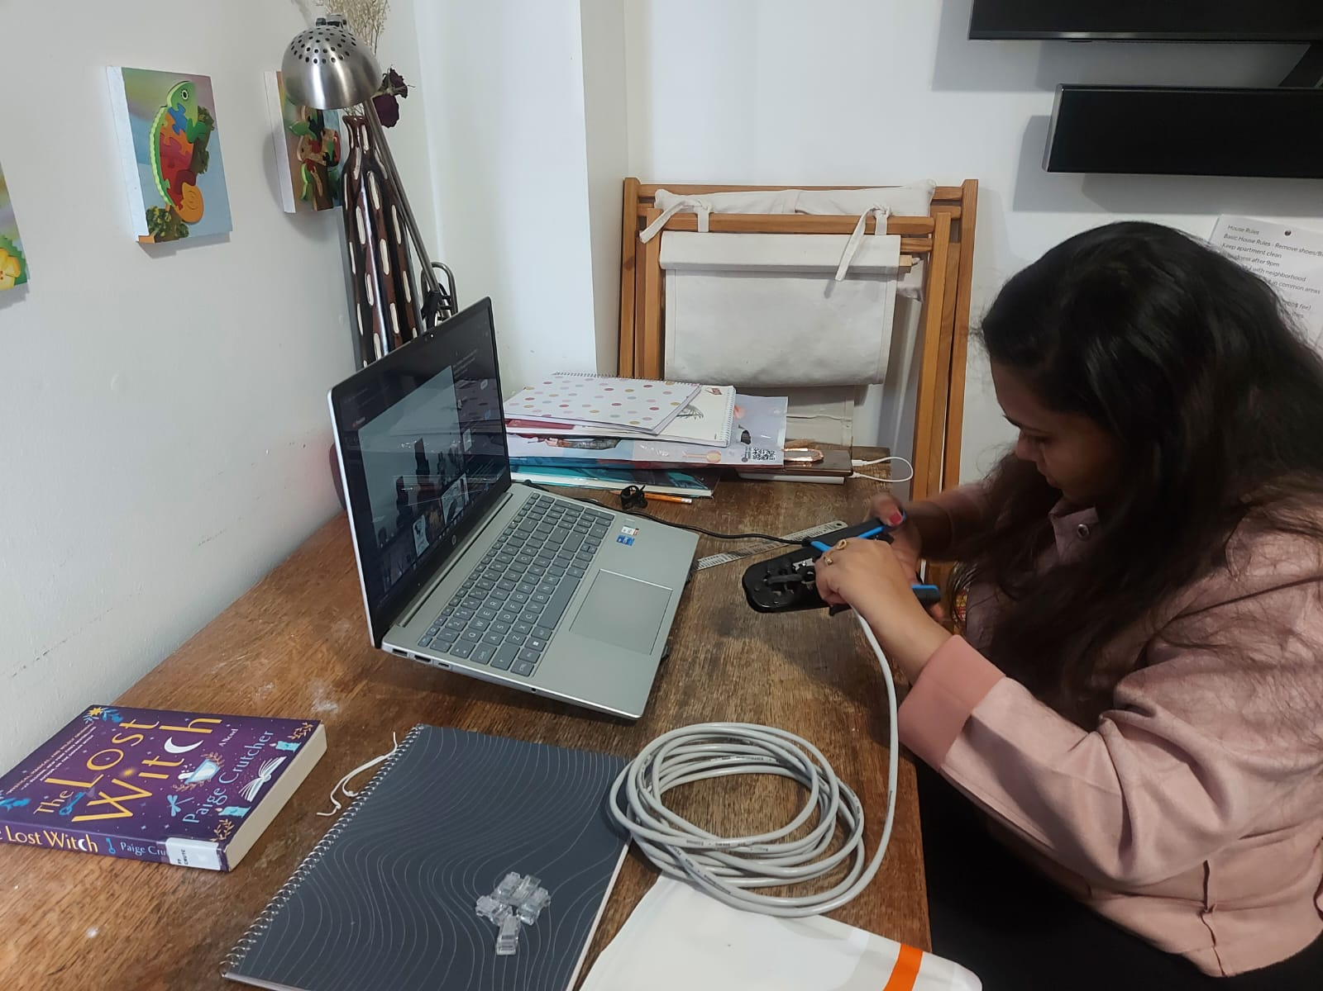
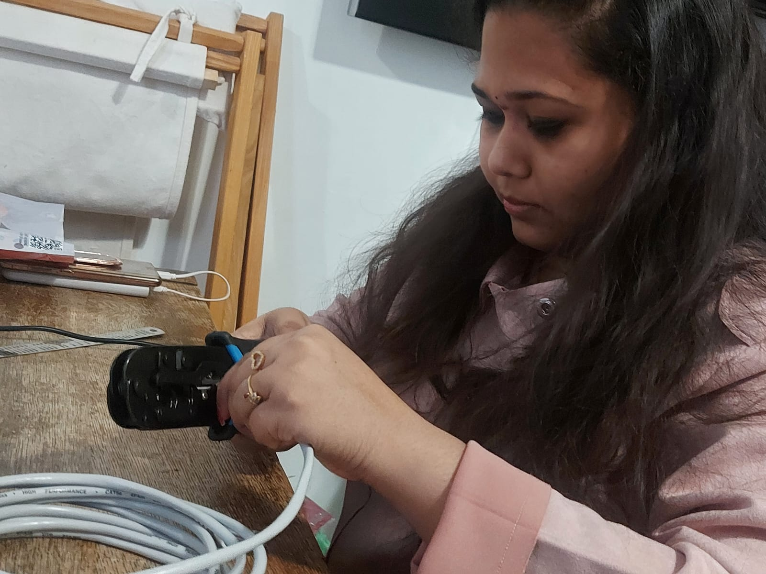
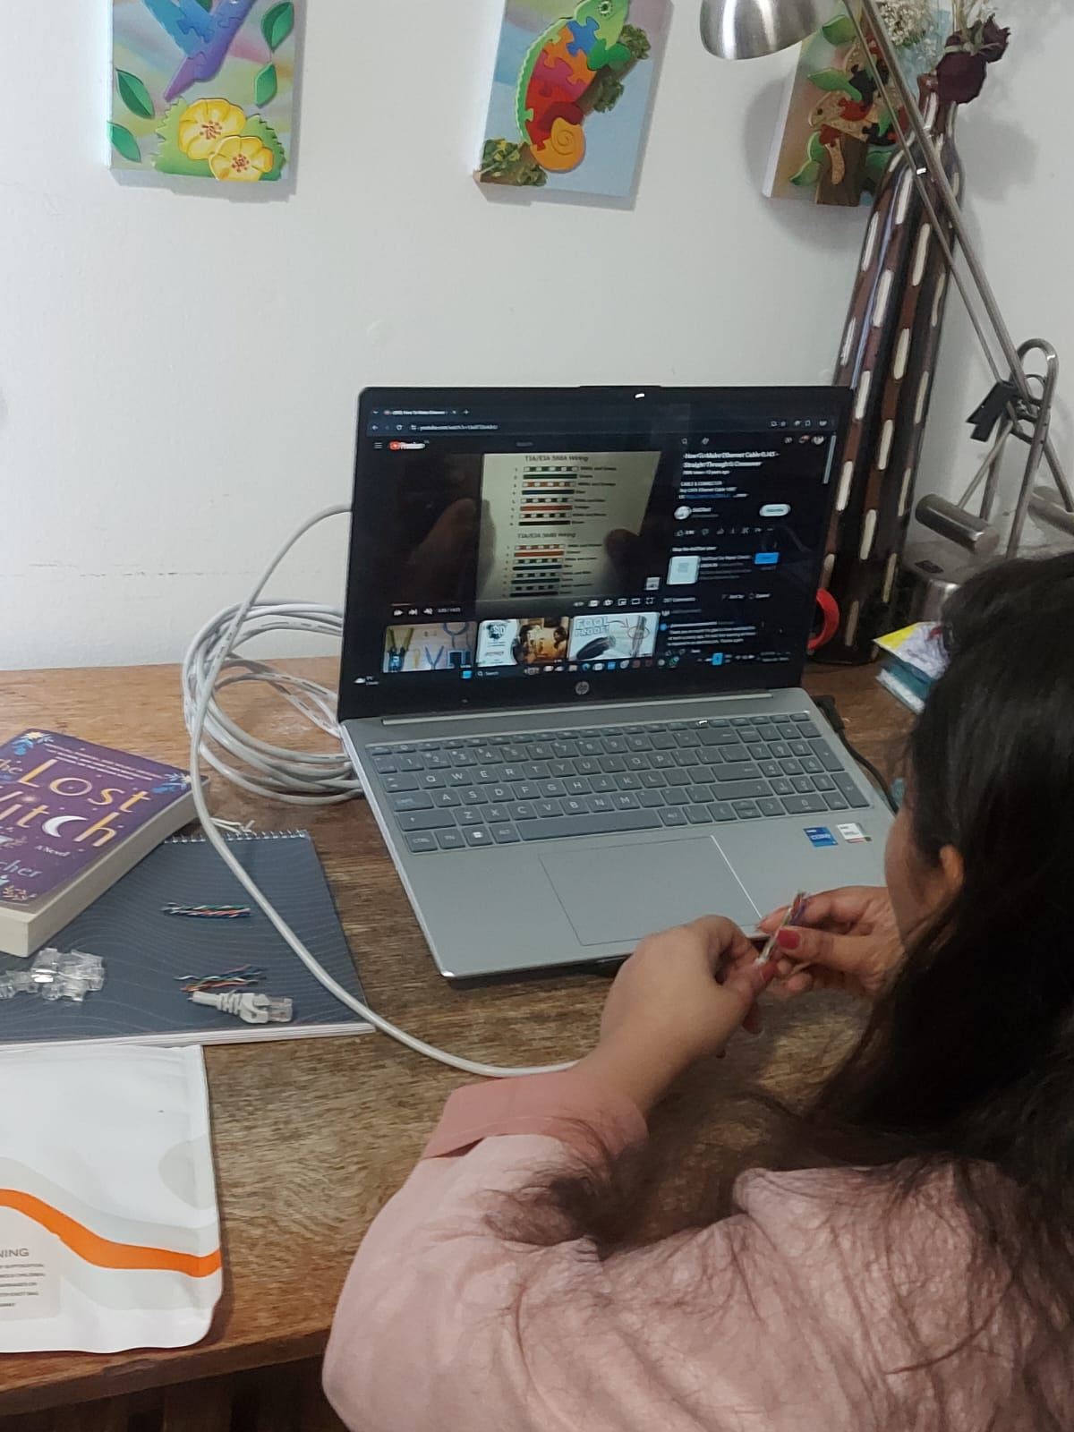
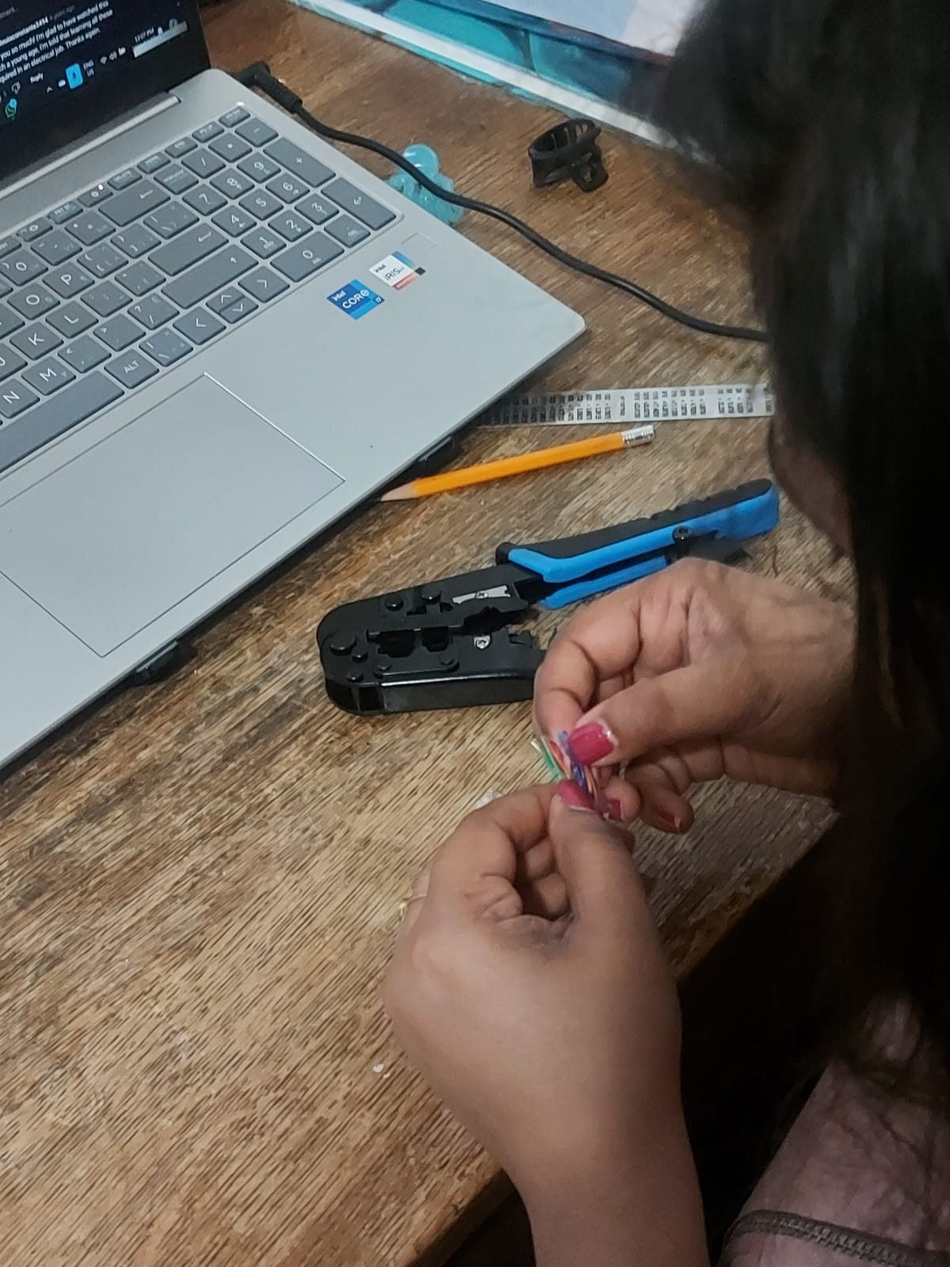

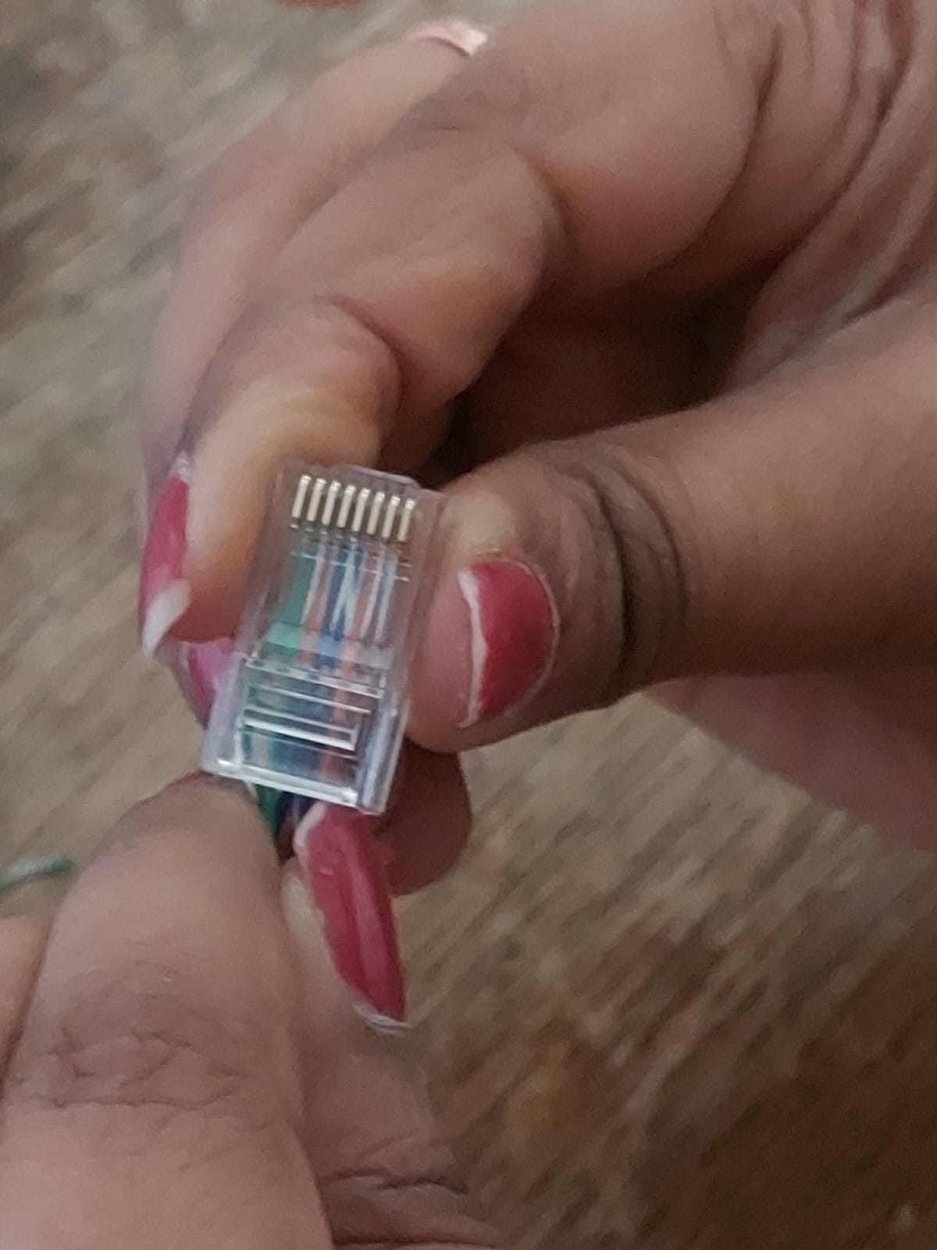
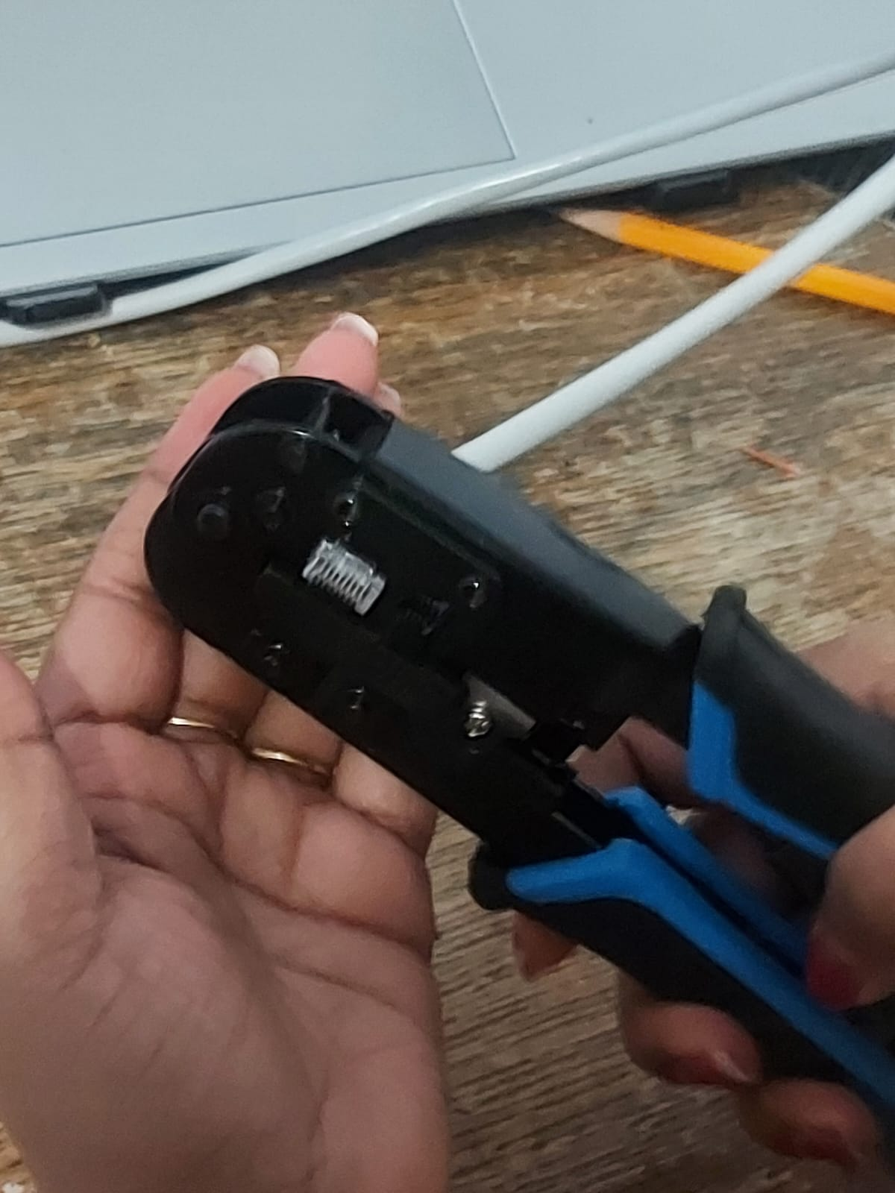
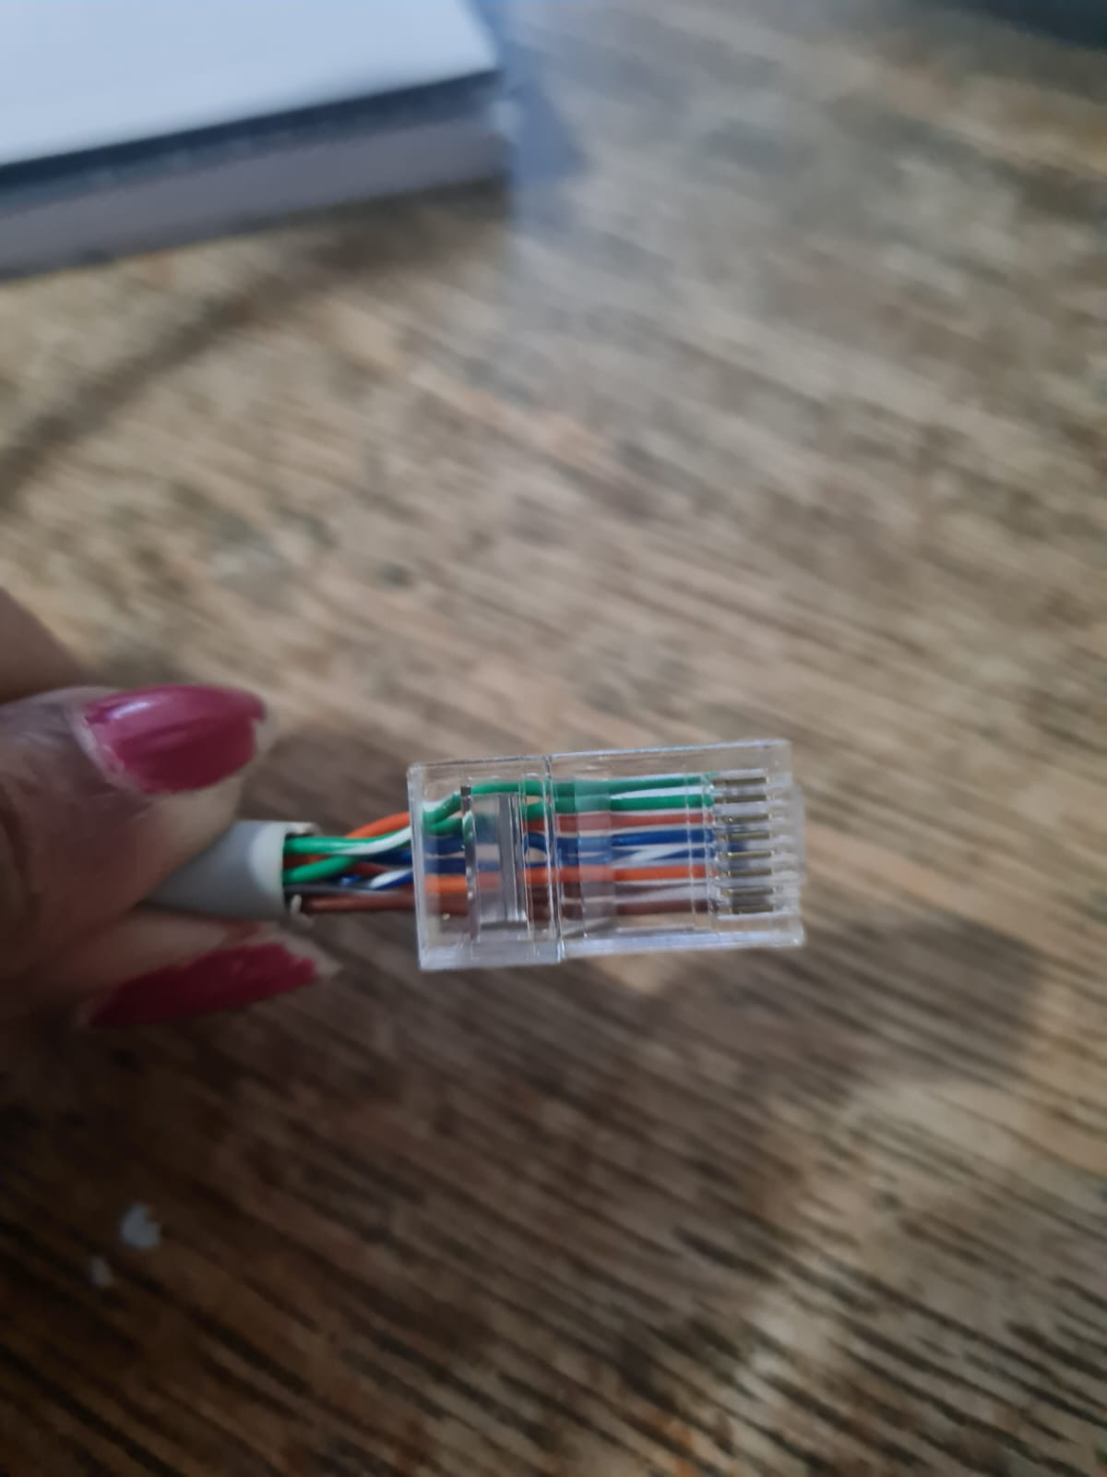
Straight Through Cable – TIA/EIA 568B

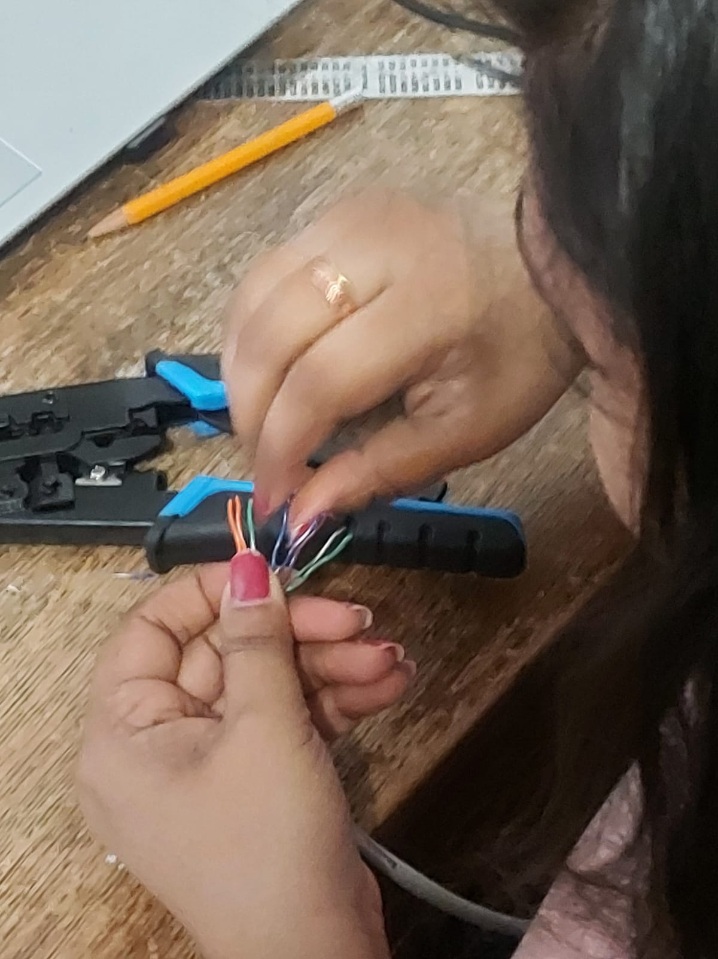
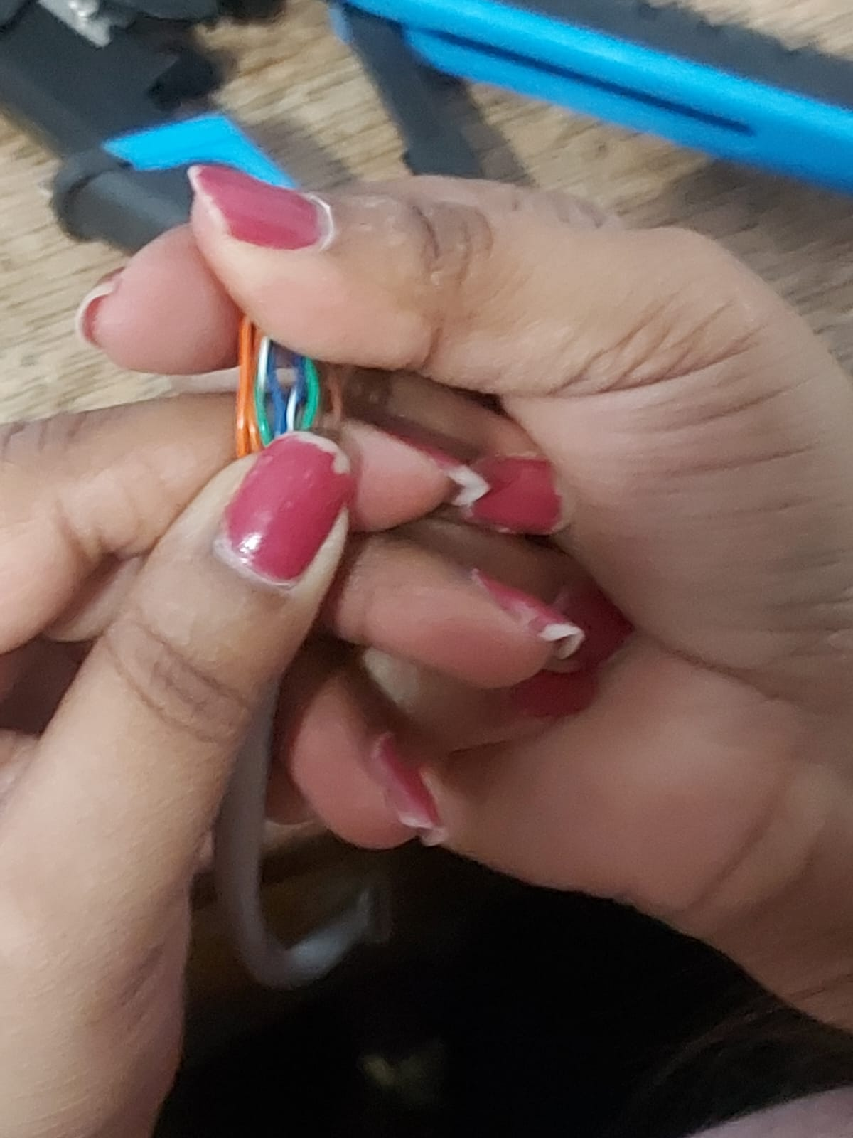
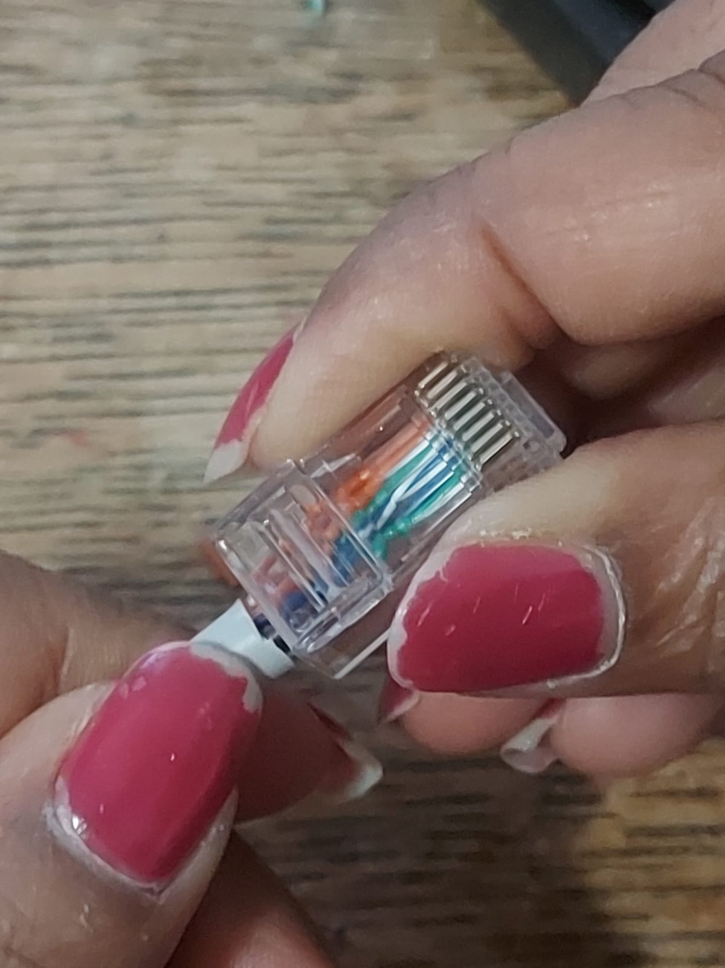
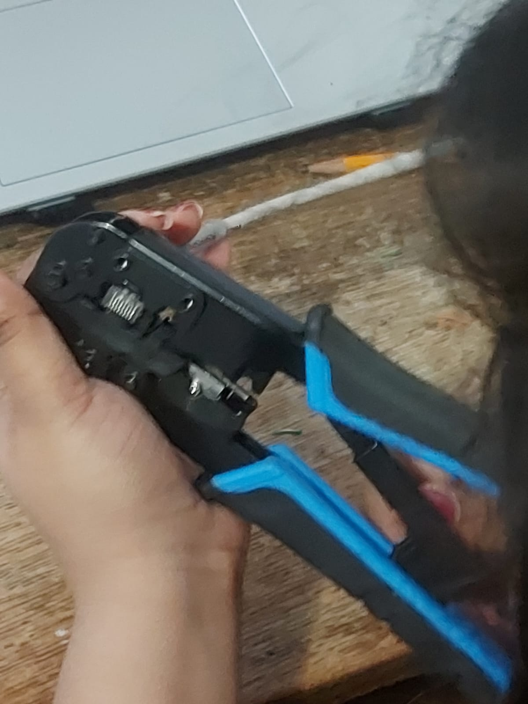
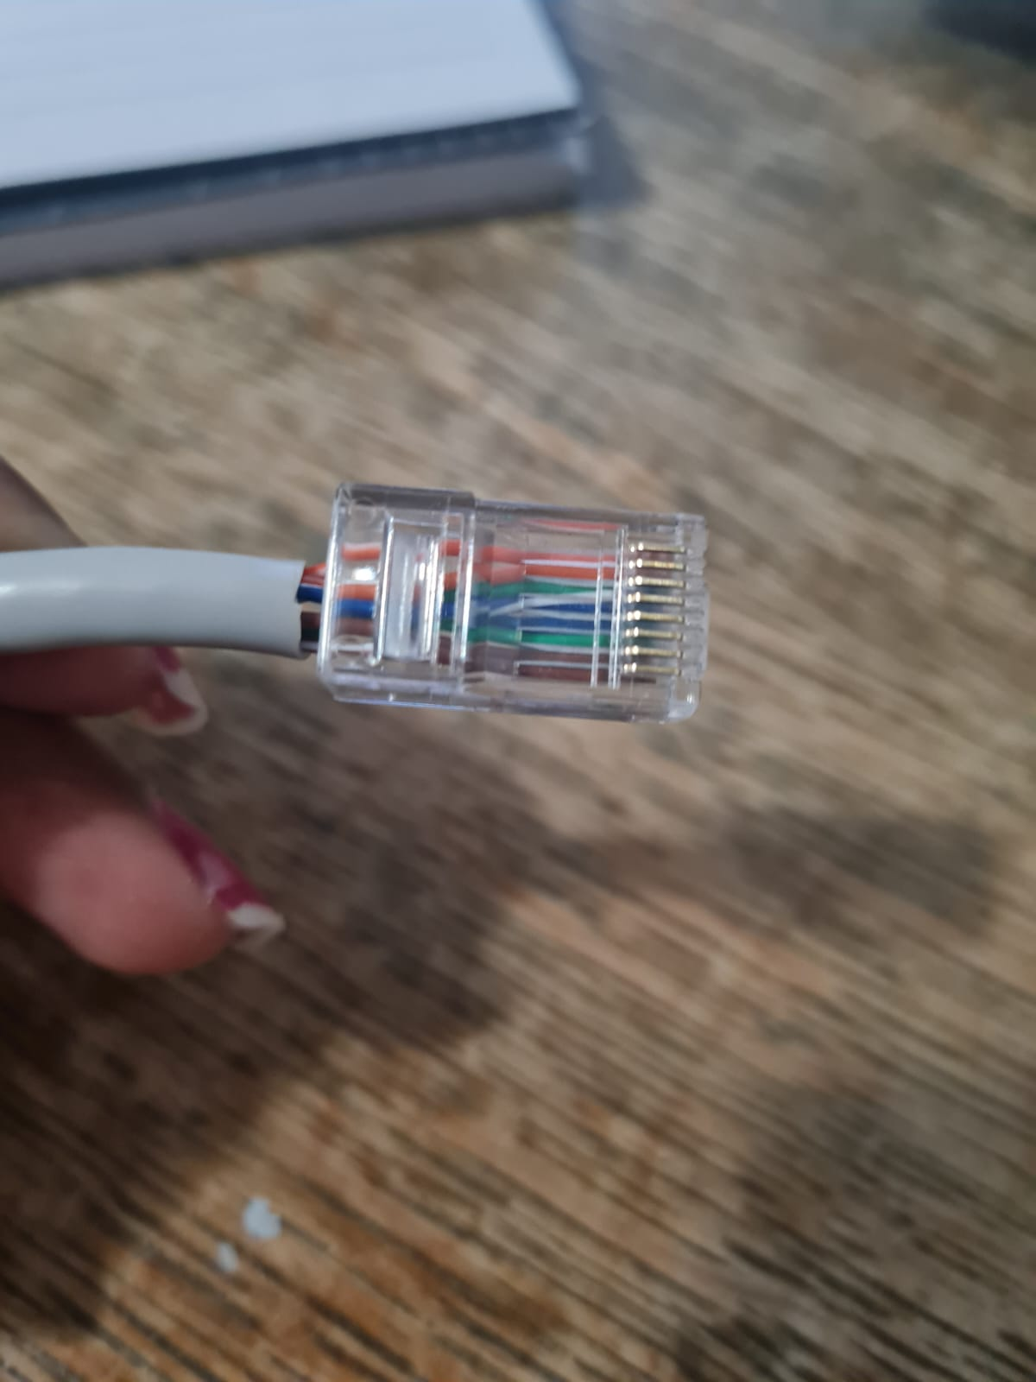

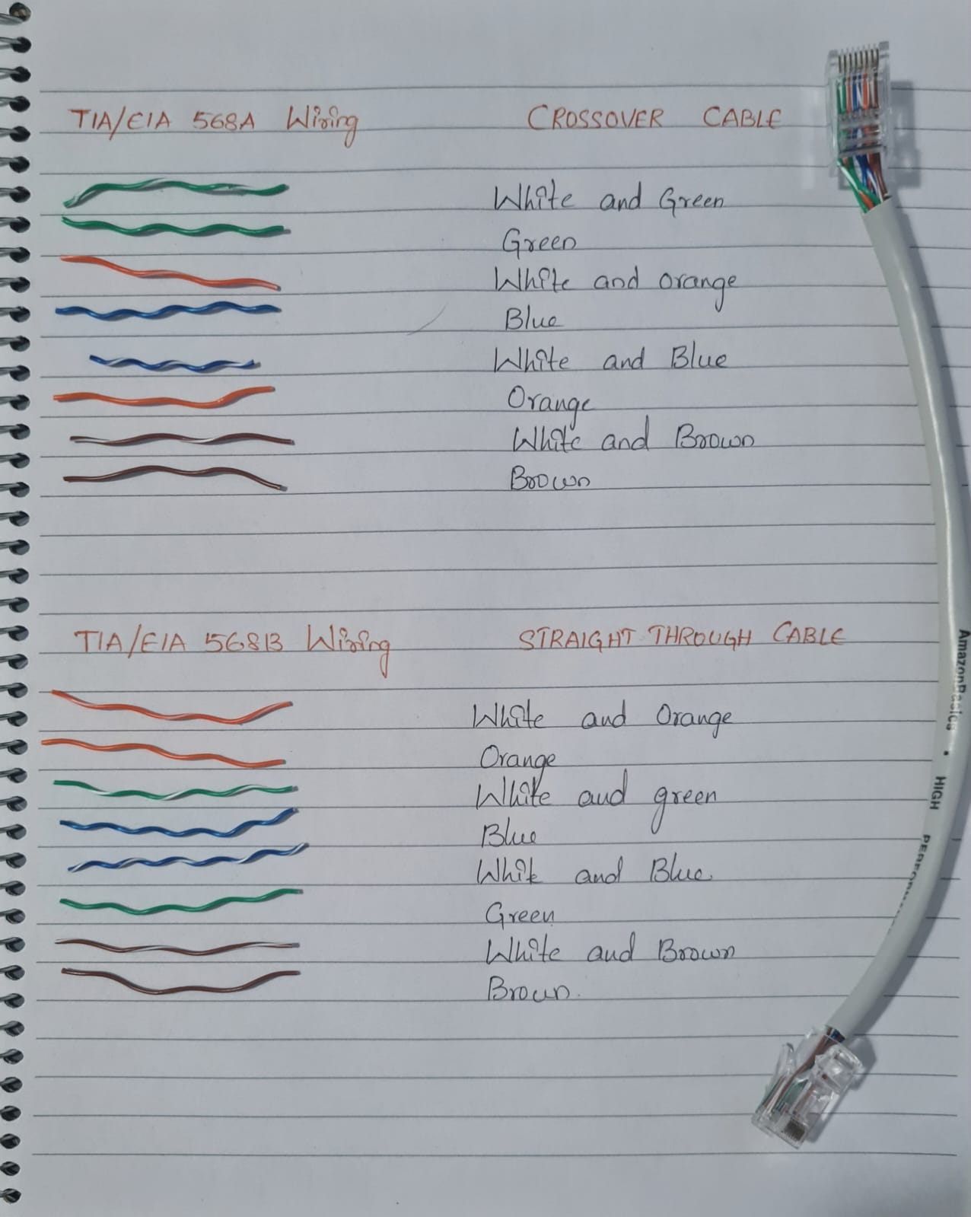

Cisco 2800 Series Router:
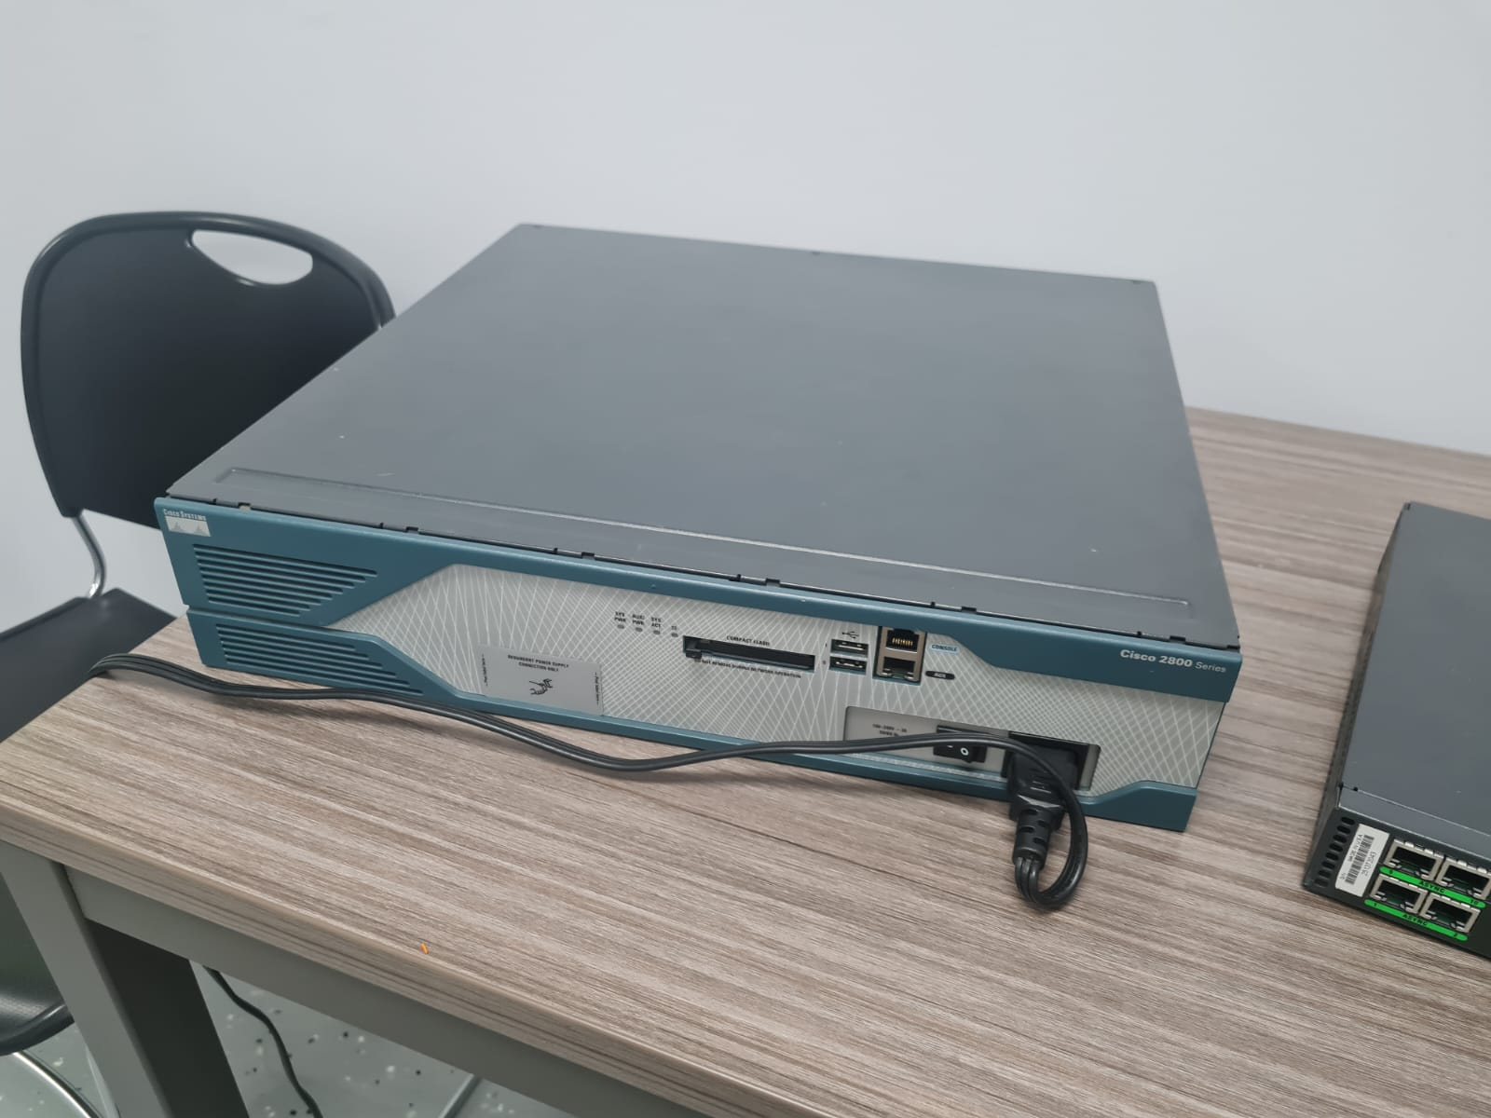
The Cisco 2800 Series Integrated Services Routers (ISR) is a family of routers that are designed for small to medium-sized businesses, enterprise branch offices, and service providers. The 2800 Series routers offer a wide range of features and capabilities, making them suitable for various networking applications.
2800 Router Specifications:
- Up to 1 GB DRAM
- Up to 256 MB flash memory
- 2 USB ports
- 2 Onboard 10/100/1000 ports
- 4 interface card slots
- AC IP power supply
- 1 console port and 1 auxiliary port
- 19 to 23-inch Rack-mounting
Cisco AS2511-RJ Router:
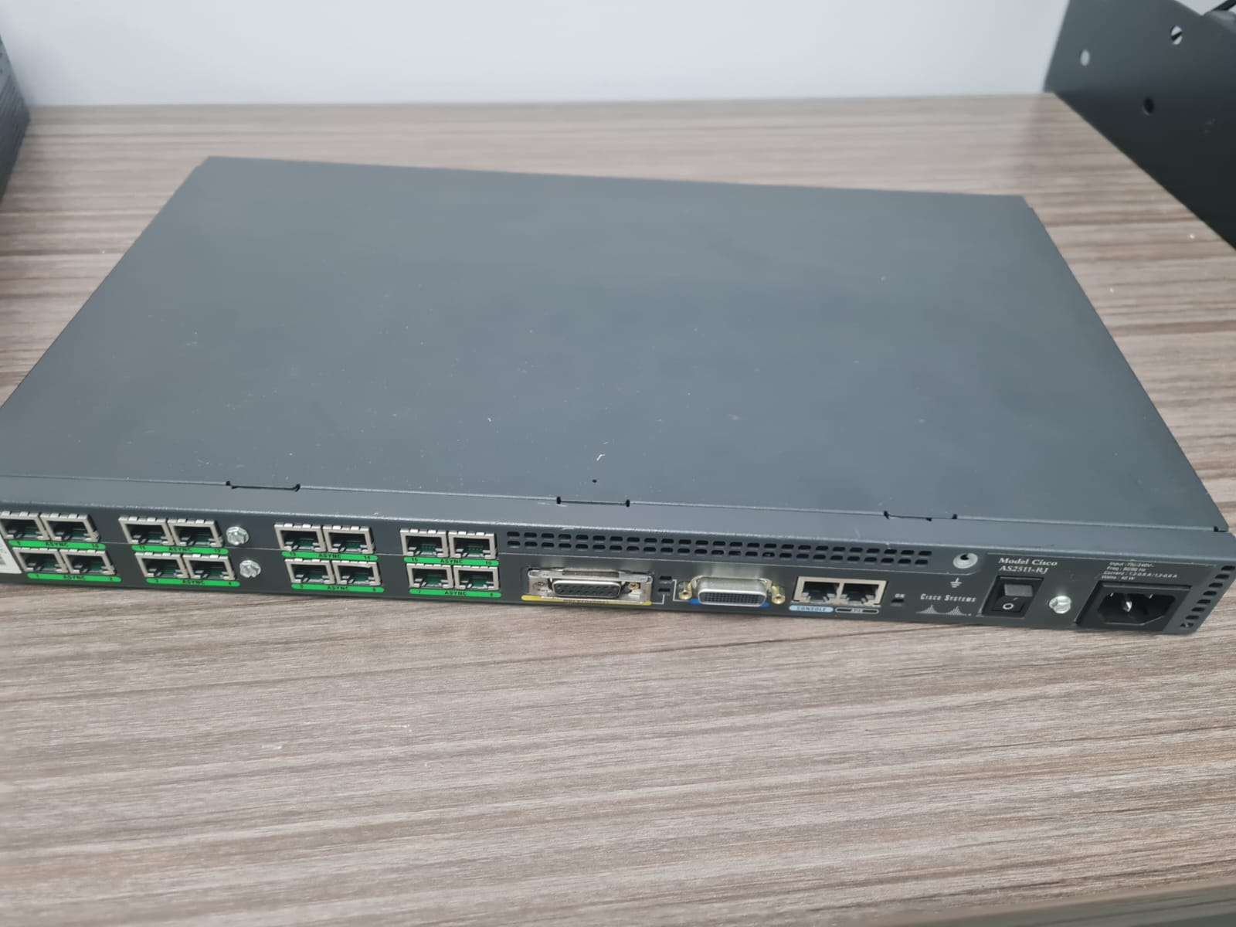
This is AS2511-RJ - this device is a Router. It is a device that is used to remote access to network equipment such as Routers, Switches, and other networking devices.

AS2511-RJ Specifications:
- 16 ports
- Rack-Mountable
- Built to Last
- Multiple Interface Types

Cisco 1921 Router:
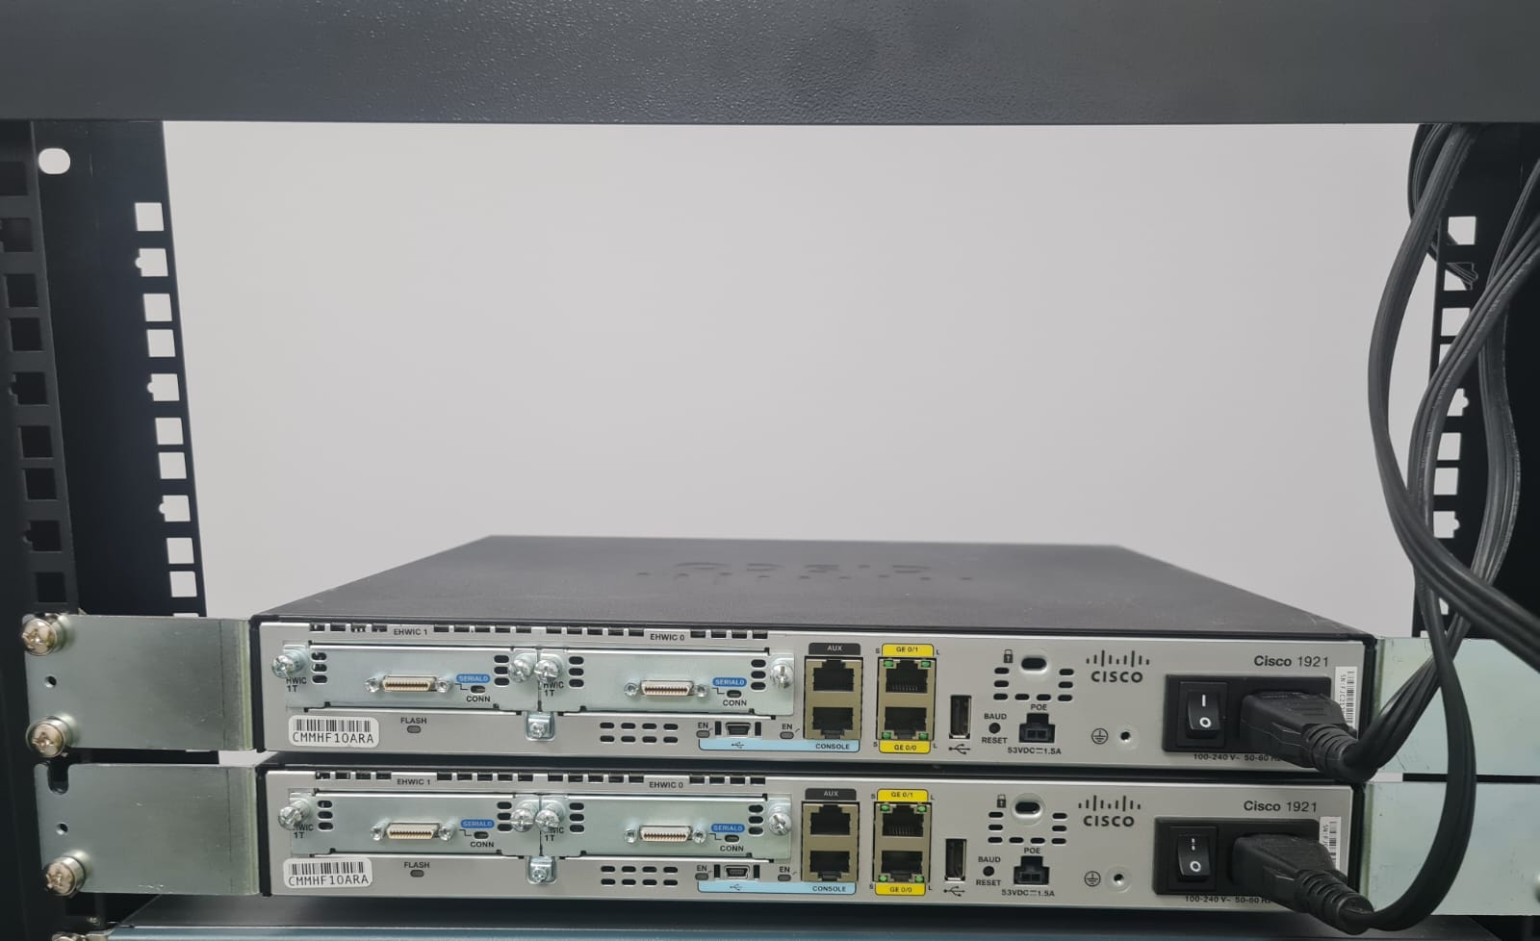
The Cisco 1921 Series Integrated Services Routers (ISR) is a family of routers that are primarily aimed at small to medium-sized businesses, branch offices, and enterprise environments.

1921 Router Specifications:
- 2 RJ-45 onboard LAN/WAN 10/100/1000 ports
- 2 EHWIC slots
- 512 MB DRAM
- 256 MB USB Flash memory
- AC integrated power supply
- External POE power supply options

Cisco Catalyst 2960 Series Switch:

The Catalyst 2960 series is a switch. These switches are made for small and medium-sized business environments. Below are its functions.

2960 Switch Specifications:
- 32 Gbps switching fabric.
- 108 Gbps forwarding bandwidth.
- Rack-Mountable-1U enclosure type!
- Forwarding rate based on 64-byte packets.
- 512 MB RAM
- 128 MB Flash memory
- Configurable up to 8000 MAC addresses
- Configurable up to 255 IGMP groups
- 24 ethernet 10/100/1000 Gigabit ports
- 8 maximum stacking number
- 80G stack bandwidth

Cisco Catalyst 3560 Series Switch:

The Cisco Catalyst 3560 series is a family of Ethernet switches designed and manufactured by Cisco Systems. These switches are typically used in enterprise and small to medium-sized business networks.

3560 Switch Specifications:
- Switching capacity up to 32 Gbps for non-blocking, wire-speed performance
- Forwarding rate up to 38.7 Mpps
- Port densities can range from 8 to 48 Ethernet ports, with options for both Fast Ethernet (10/100 Mbps) and Gigabit Ethernet (10/100/1000 Mbps) interfaces.
- Power over Ethernet (PoE) allows the switch to provide power to connected devices such as IP phones, wireless access points, and IP cameras.
- Supports VLAN (Virtual Local Area Network) functionality.
- Quality of Service (QoS) feature enables prioritization of network traffic based on different criteria such as packet type, source/destination address, or application.
- Supports Rapid Spanning Tree Protocol (RSTP) and Virtual Router Redundancy Protocol (VRRP) to ensure high availability and redundancy in the network.
- Switch can be managed through a command-line interface (CLI) or a web-based graphical user interface (GUI).
- It also supports SNMP (Simple Network Management Protocol) for network monitoring and management.

Cisco Catalyst 3750 v2 Series PoE-24 Switch:

The Catalyst 3750 v2 series is a line of Ethernet switches. This series is an iteration of the original Catalyst 3750 series and offers enhanced features and performance compared to its predecessor.

3750 V2 series switch:
- Managed switch type
- Supports Quality of Service (QoS)
- 24 basic switching RJ-45 ethernet ports
- 1000 VLANs
- Supports MAC address filtering.
- 32MB Flash Memory
- 8 Gbps bandwidth
- Wired connectivity technology
- 32 Gbps switch fabric speed.

Server: Server wasn’t available in the lab.

